Angela Ormson
CS 210 – Dr. Savard
6/21/2026
Corner Grocer Item Tracking Program Design and Functionality
The Corner Grocer Item Tracking Program was designed using object-oriented programming principles and separation of responsibilities to improve readability, maintainability, and testing. Instead of placing all functionality in a single file, the program was divided into three classes: ItemTracker, FileManager, and Menu. Each class is responsible for a specific portion of the program, making the code easier to understand and modify.
The ItemTracker class manages the grocery item frequency data. A map data structure was used to store each item and its corresponding purchase count. When an item is read from the input file, the AddItem() function either adds the item to the map or increases its frequency if it already exists. The class also contains functions for searching through item frequencies, displaying all frequencies, and generating the histogram output required by the project.
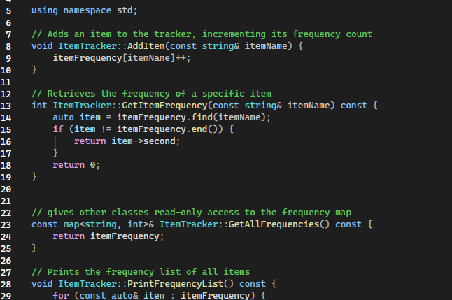
The FileManager class handles all file input and output operations. During program startup, the LoadItemsFromFile() function reads data from the provided CS210_Project_Three_Input_File.txt file and sends each item to the ItemTracker object for processing. After the frequencies have been calculated, the CreateBackupFile() function automatically generates the required frequency.dat backup file. Separating file operations into their own class keeps the ItemTracker focused only on data management.
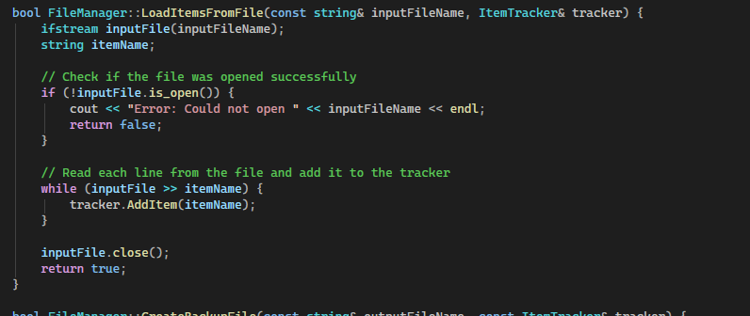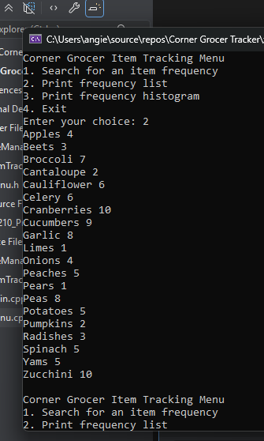
The Menu class manages all user interaction. It displays the menu options, validates user input, and calls the appropriate ItemTracker functions based on the user’s selection. Input validation was included to prevent runtime errors caused by invalid menu entries. If a user enters a value that is not a valid menu option, the program displays an error message and prompts the user again.
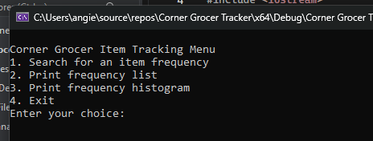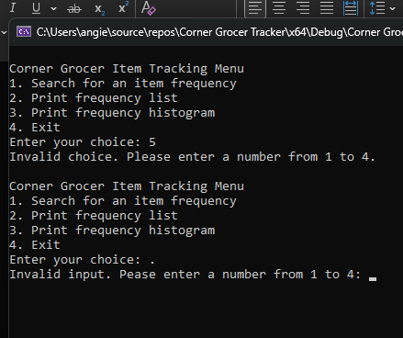
During testing, a validation error occurred based on whether the itemName entered was capitalized or not. When the user entered “Apples”, the count was four, but if “apples” was entered, the count was zero. The txt file was presented with uppercase data so to account for this logic error, a single line of code was inserted— if (!itemName.empty()) itemName[0] = toupper(itemName[0]); —to change the input to a capitalized itemName.
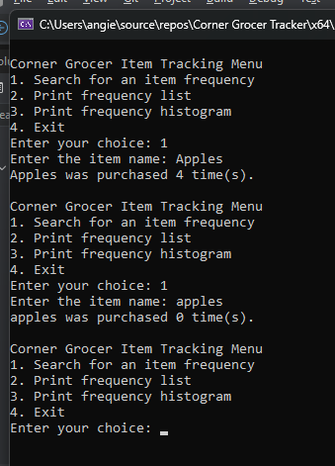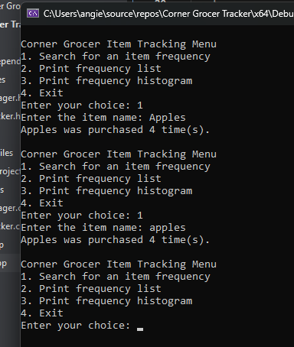
The main.cpp file serves as the program’s entry point and coordinates the interaction between the classes. It creates the ItemTracker, FileManager, and Menu objects, loads the input data, creates the backup file, and starts the menu system. This design follows the principle of separation of responsibilities because each class performs a single primary function. As a result, the program is easier to test, debug, and maintain while satisfying all project requirements.

